# Upload MSIX package to files share

In this article, we are going to cover the process of uploading an [MSIX image](https://docs.microsoft.com/en-us/azure/virtual-desktop/app-attach-glossary#msix-image) to the [MSIX share](https://docs.microsoft.com/en-us/azure/virtual-desktop/app-attach-glossary#msix-share).

# Requirements

MSIX package that has been expanded to MSIX image via the MSIXMGR tool, as described [here](https://docs.microsoft.com/en-us/azure/virtual-desktop/app-attach#generate-a-vhd-or-vhdx-package-for-msix).

MSIX share on Azure Files (AF) storage account, as described [here](https://techcommunity.microsoft.com/t5/windows-virtual-desktop/step-by-step-guide-on-computer-account-auth-for-azure-files/m-p/1855164).

Permissions to download and install Azure Storage Explorer.

Permissions to upload files to MSIX share.

Existing WVD host pool with at least one running virtual machine (VM).

# Process overview

1. Confirm at least one VM in the host pool is healthy and turned on
2. Obtain the (local) path to the MSIX image
3. Download and install Azure Storage Explorer
4. Upload MSIX image to MSIX share

# Healthy host

To perform the validation of an MSIX image Windows Virtual Desktop requires that at least one VM is present in that host pool. Its status must be **Available** and it must be on.

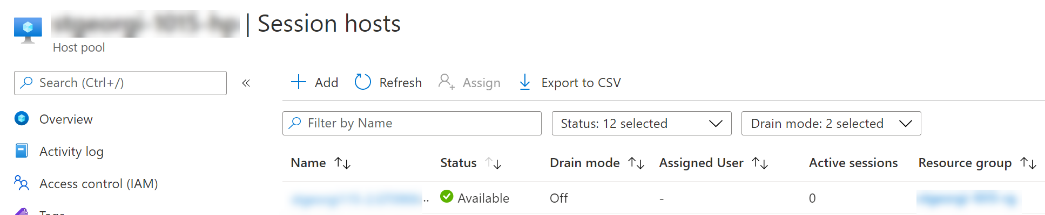

# MSIX image

We will presume that that MSIX image has been created on the local machine. Its file type is CIM and the local path is C:\TEMP.

# Download and install Azure Storage Explorer

To download the Azure Storage Explorer in a browser navigate to <https://azure.microsoft.com/en-us/features/storage-explorer/>.

Click on the **Download now.**

When prompted accept and start the installation. Follow the wizard to complete this installation.

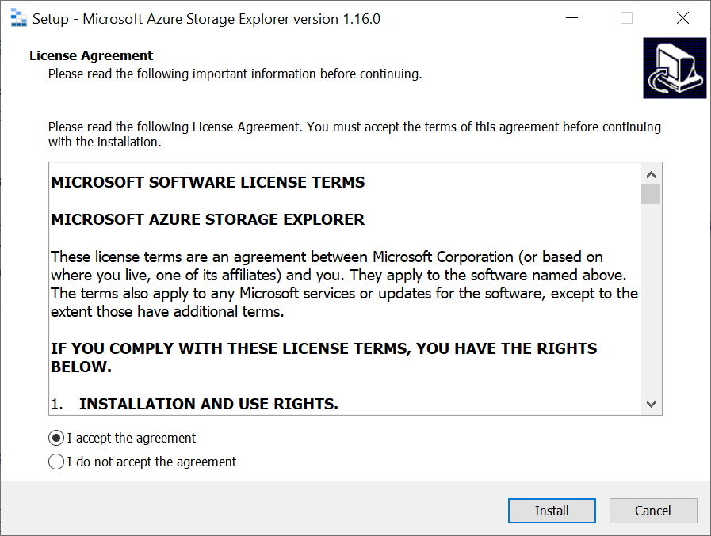

Start Azure Storage Explorer

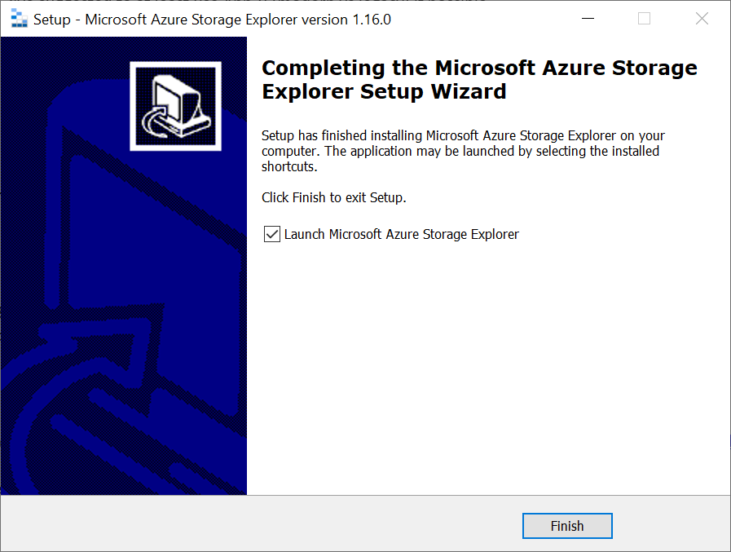

Click the **Open connect dialog.**

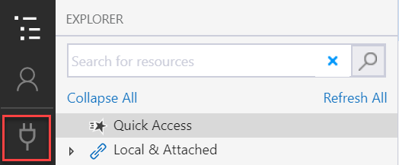

Select **Add an Azure Account.** This will open the Azure AD authentication dialog. Enter credential of a user that has **permissions** to the storage account that is hosting the MSIX share.

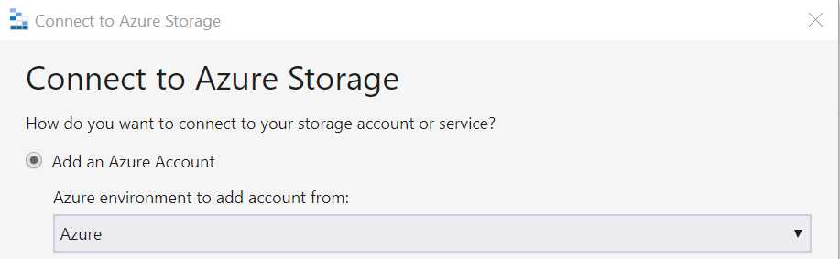

Once successful authentication is completed subscription will be list.

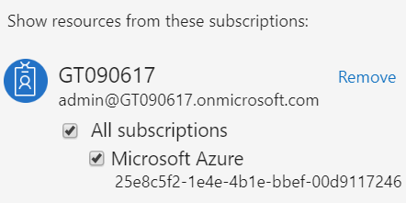

**Note:** Incorrect credentials.

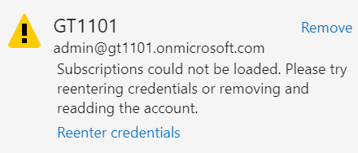

Click on **Toggle explorer**. This will list all storage account and disks.

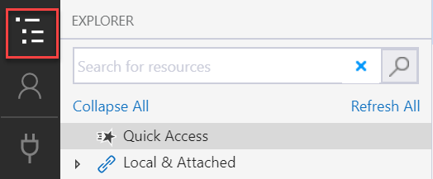

Select a storage account. Select a file share in that storage account.

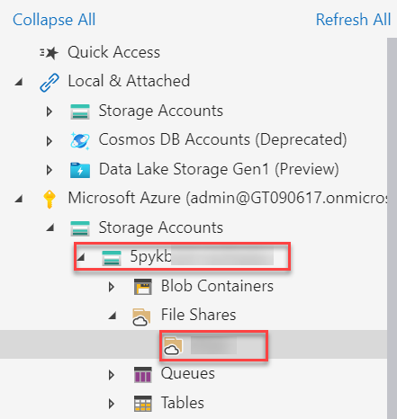

Click the **Upload** button and select **Upload Files…**

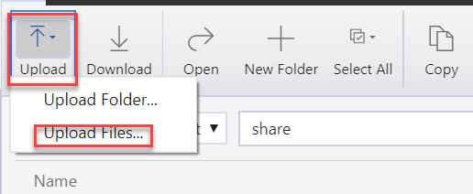

Using **Upload Files** dialog select a MSIX image file from the local machine and upload it.

